  Workfront Data requirements  5.0 | High Level summary  Centralizing Workfront data elements into a streamlined business-ready dataset to power FY27 Attribution Models and provide Orchestration Teams with actionable insights for Seller Enablement.  Stephanie Boyd  Digital Marketing Manager

Revision History
Date | Version | Description | Author
13/05/2026 | 1.0 | Initial Draft | Amanda Pattenden
19/05/2026 | 2.0 | Reviews from Jessica | Amanda Pattenden
19/05/2026 | 3.0 | Removal of references to Flattened and Denormalized tables as per Christy | Amanda Pattenden
21/05/2026 | 4.0 | Updated to field names after confirmation and validation from Calin | Amanda Pattenden
21/05/2026 | 5.0 | Amendments with additional fields being populated in Content Format | Amanda Pattenden

Table of Contents

1. Introduction 3
Executive Summary – Overview 3
Problem Statement – Why? 3
Vision – What? 3
Benefit Summary – Who? 4
2. Scope and Limitations 4
In-Scope 4
Out of Scope 4
Assumptions 4
Dependencies 5
Key Objectives 5
3. Business Process 5
Business Process – As Is (Current State) 5
Business Process – To Be (Future State) 6
4. Stakeholder Requirements 6
Stakeholders 6
GTMRP Requirements 6
Project Data Capture 7
Channel Data Capture 8
Content Data Capture 10
Appendix C 11
5. Refresh & Timelines 13
6. Governance and Ownership 14
7. Glossary of Terms 15
Glossary 15
8. Approvals and Sign-Off 15
Document Reviewers 15
9. Appendix 16
Appendix A 16
Appendix B 16
Appendix C 16
Appendix D 16
Appendix E 16

- Introduction

Executive Summary – Overview
The Workfront data architecture is structured as a complex relational database storing strategic metadata. This native configuration creates significant barriers for downstream teams who need to extract and utilize activation data for attribution modeling, seller enablement, and leadership reporting.

This Business Requirements Document (BRD) defines the functional requirements for delivering a governed, business-ready, and queryable Workfront dataset. The goal of this initiative is to ensure that reporting and orchestration teams can seamlessly access structured Project, Content, and Channel activation data with clear business terminology, removing the operational friction of navigating the underlying Workfront schema.

We acknowledge that this business-ready Workfront dataset is a foundational prerequisite for future enterprise integration efforts, including UTM bridging, engagement matching, and legacy ID continuity. Our requirements are strictly scoped to ensure the data output is logically structured to enable those downstream workstreams without owning their final execution.

Problem Statement – Why?
- Metadata is inaccessible: Strategic fields (e.g. Contact Type, Contact Sub Types) are stored as key-value pairs, not queryable columns. Every analyst must write their own pivot logic, introducing inconsistency.
- No single source of truth: Without a unified, governed dataset, teams pull Workfront data through manual exports and ad-hoc queries — creating data silos and conflicting metrics.
- Barrier to attribution: The Attribution Model and leadership reporting cannot slice performance by strategic dimensions (program, technology, stakeholder unit) because the data isn't structured to support it.
- Operational friction: Reporting and orchestration teams spend disproportionate time on data preparation rather than analysis and action.

Vision – What?
Our vision is to transform Workfront’s complex relational architecture into a fully governed, high-performance Dataset, that serves as the single source of truth for all marketing activations through central intake. By engineering an accessible, query-ready data structure, we will eliminate the need for redundant pivot logic and manual data preparation.
This approach will provide seamless, query-ready access to critical strategic dimensions—such as Program, Technology, and Stakeholder Unit—empowering our reporting teams to deliver high-fidelity attribution models and enabling orchestration teams to drive automated seller enrichment within SFDC. Ultimately, this initiative will bridge the gap between raw operational data and the strategic leadership views required to measure and scale the business.

Benefit Summary – Who?
DOPT: Benefits from a reduction in query complexity, leading to faster turnaround for Attribution Modeling.
CETO/Tray: Gains a reliable data feed to drive Seller Enablement actions within Salesforce, ensuring sales reps have the right content context.
Marketing Teams: Ensures strategic alignment of data across the enterprise by standardizing how we track Workfront activities in alignment with MSP.

- Scope and Limitations

In-Scope
- Data Usability: Workfront metadata transformation from a complex relational structure into clearly defined, queryable data fields.
- Requirements Gathering: Identification of the specific GTMPR (Go to Market Readiness & Performance) data requirements.
- Strategic Data Mapping: Defining the data elements relating to Workfront that are essential for high-fidelity reporting and Attribution Models.
- Seller Enablement: Defining the Workfront attributes required to feed into SFDC (Salesforce) from Tray.io
- Entity Alignment: Mapping the relationship between Workfront Projects and Tasks to ensure ID integrity

Out of Scope
- Attribution Model Logic: The specific algorithmic alignment or weighting logic used within the final attribution models, these are owned by DOPT
- Cross-Table Joins: joining to engagement data (Eloqua, SFDC, web logs), UTM bridge construction, and legacy CTT ID translation are downstream workstreams that depend on this dataset but are not part of making Workfront data business-ready
- Database Schema Design: The physical architecture, indexing, partitioning, or specific formatting (such as table denormalization or flattening) of the final data delivery.
- Operational Reporting: Requirements for day-to-day Workfront productivity metrics or the specific needs of the Workfront BCO (Christy Parker).
- Front-end Visualization: The design, development, and maintenance of dashboard visualizations are out of scope; this project focuses strictly on the underlying data layer.

Assumptions
These are the underlying conditions we believe to be true for this project to succeed:

- It is assumed that the Workfront Project and Task levels are being populated with the required Strategic IDs (Project, Content, Channel) at the point of entry.
- We assume that the unique identifiers used in Workfront are persistent and align with the ID formats used in our attribution and SFDC environments.
- This governed dataset is intended to be the definitive source for attribution and lead enrichment related Workfront data, superseding manual exports or ad-hoc reports.
- It is assumed that the source field names and attributes referenced from Workfront in this document have been accurately sourced from the Workfront Data Dictionary, and that the dictionary represents the current, up-to-date configuration of the live operational environment.

Dependencies
The successful delivery of this data source relies on the following factors:

- The project is dependent on the timely sync of raw Workfront data into our central data warehouse (e.g., Snowflake).
- Any changes to the Workfront API used to pull raw tables may impact the integrity of the flattened data set.
- Finalizing the data elements requires active sign-off from the Reporting and Orchestration teams to ensure the flattened attributes meet their specific modeling and enablement criteria.
- The accuracy of this table depends on the business process governance that mandates the inclusion of Channel and Content IDs within Workfront tasks.

Key Objectives
- The primary goal of this initiative is to eliminate the technical friction associated with Workfront's native data structure.
- Simplify the complexity of the Workfront relational schema into a user-friendly data structure that is accessible to non-expert SQL users.
- Ensure a 1:1 mapping between Workfront activities and our strategic Project, Content, and Channel IDs to enable accurate downstream stitching.
- Streamline the data retrieval process for the Reporting and Orchestration teams, reducing the time spent on data preparation for Attribution Modeling and Lead Enrichment
- Establish a governed, repeatable dataset that scales with business needs

- Business Process

Business Process – As Is (Current State)
WorkFront Data is not currently utilized for attribution models or lead enrichment

Business Process – To Be (Future State)
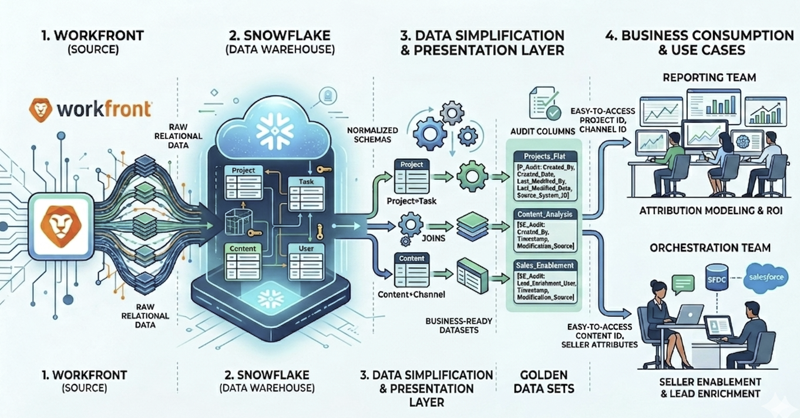

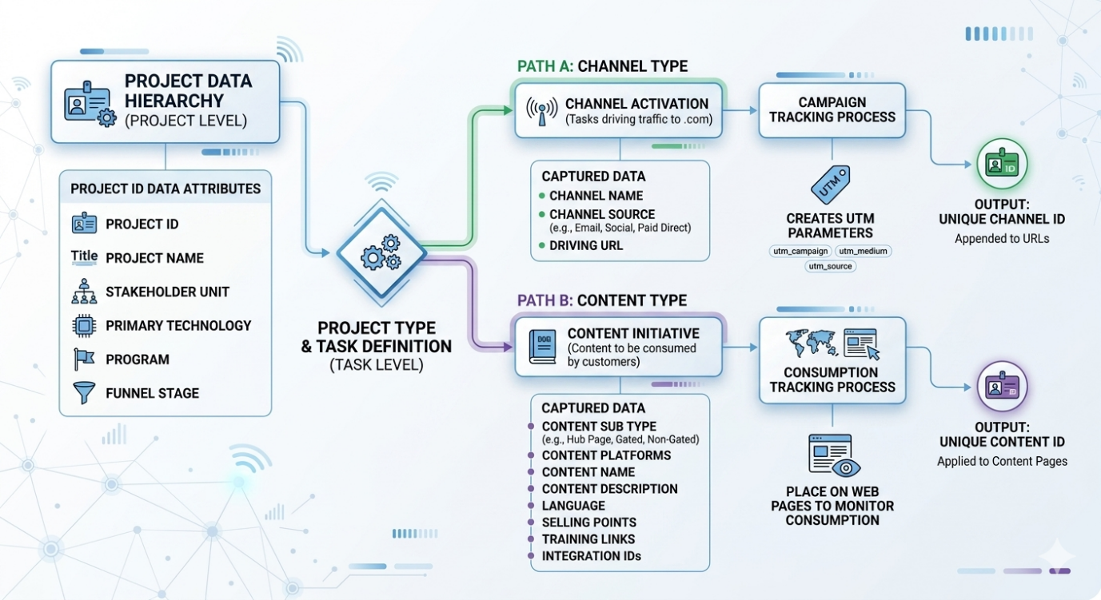

- Stakeholder Requirements

Stakeholders
Stakeholder | Code | Description
Go To Market – Readiness & Perfomance | GTMRP | Requirements from the GTMRP team to support the ability to capture workfront data for Attribution Modeling and Lead Enrichment
 | GEN | Consistent general data values for all projects
 | CHL | Channel Data Related Requirements
 | CON | Content Data Related Requirements

GTMRP Requirements

GMTRP001: As a Data Analyst, I want to have a business-ready, structured Workfront dataset that utilizes clear business terminology for column names and minimizes the need for complex table joins, so that I can easily understand and query the data to accelerate reporting, eliminate repetitive data preparation, and seamlessly support leadership views of the business.

GMTRP002: As a Data Analyst, I want to have a comprehensive, centralized metadata repository and data dictionary that clearly defines every field int the delivered dataset —including its raw Workfront source-of-truth origin, data type, and the transformation logic used during denormalization, so that I can easily self-serve answers to my data questions, eliminate conflicting interpretations of metrics, and ensure consistent, accurate logic is used across all reporting and attribution teams.

GMTRP003: As a Data Governance Lead, I want to implement a formal governance framework and a structured intake process for the governed data source so that reporting and orchestration teams can easily request new data elements or logic modifications, ensuring the table adapts to evolving business requirements while maintaining its integrity as a stable single source of truth.

GMTRP004: As a Data Governance Lead, I want to establish a recurring review and audit cycle for the strategic data elements against shifting strategic priorities, so that any changes to how the business defines Content, Channel, or Project IDs are immediately identified and updated in the transformation logic with minimal latency, keeping the dataset continuously accurate and reliable for leadership reporting.

GMTRP005: As a Data Analyst, I want to provide the Reporting and Orchestration teams with comprehensive documentation and Standard Operating Procedures (SOPs) for the business-ready dataset, so that end-users can independently interpret data lineage and utilize the table for self-service analysis, minimizing operational friction and eliminating redundant cross-functional support queries.

General Projects Data Capture

GEN001: As a Data Analyst, I want to capture and aggregate strategic data elements—including all elements listed below from the Workfront relational database into a standardized, accessible data output structure, so that I can accurately segment, report, and model data for each specific customer activation ensuring all reporting is directly aligned to leadership views of the business.

Workfront Field Name | Business Term | Definition | Business Logic
uap project id | Project ID | For every new project, there will be a unique project ID | Stakeholder Unit Acronym + 6 numbers (000001) -
uap stakeholder unit | Stakeholder Unit | The organization within Cisco initiating the Workfront Request. If requesting on behalf of another stakeholder, should select that stakeholder. | Single Select List of Values
uap primary technology | Primary Technology | The main technology being targeted in this activation. | Single Select List of Values
uap program | Program | The primary marketing program aligned to the activation. | Single Select list of values
uap funnel stage | Funnel Stage | Phase in the customer journey (Awareness → Decision) | Single Select List of values

GEN002: As a Data Analyst, I want to capture and aggregate standard project details and related operational context from the normalized Workfront tables and consolidate them into standardized, accessible data output structure, so that I can easily access a single-source view to analyse the specific timing and details of each activation without needing complex relational joins, enabling faster reporting and better

Workfront Field Name | Business Term | Definition | Business Logic
uap project type | Project Type | The activation type selected from the DART homepage. | Backend data capture; determines which conditional fields display
uap campaign start date | Project Start Date | The date the project is due to launch.
uap campaign end date | Project End Date | The data the project is due to finish.
uap country band | Country Band | Grouping of countries by investment priority. | Multi Select List of Values
uap country_ms | Country | Countries the initiative is targeting. | Multi Select List of Values
uap language | Language | Language of the activation. | Automated based on Country selection. See Appendix C

GEN003: As a Data Analyst, I want to capture and ingest technical audit columns from the native Workfront relational tables into the reporting data layer, so that I can maintain high-fidelity data integrity, ensure full accountability for record updates, and provide an end-to-end traceability trail for all data elements used in attribution and seller enablement.

Workfront Field Name | Business Term | Definition | Business Logic
entry date | Created Date | Date the project in Workfront was created
last update date | Modified Date | Last date the Workfront project was amended.
entered by | Created By | The username that created the project.
last updated by | Modified By | The last username that amended the project.

Channel Data Capture

Examples of Channel Data Capture

CHL001: As a Data Analyst, I want to capture the Workfront attributes that identify that a project is a channel activation via the Project Type, so that I can ensure the output dataset is correctly categorized and each customer activation is correctly categorized for attribution modeling and leadership reporting.

Workfront Field Name | Business Term | Definition | Business Logic
uap project id | Project ID | Unique identifier for the master Workfront project. | Every new project receives a unique Project ID
uap project type | Project Type | The activation type selected from the DART homepage. | Backend data capture; determines which conditional fields display
uap Asset ID | Channel ID | Unique identifier for the channel activation, generated by Workfront and stored in a custom field. Serves as the primary identifier to tie back to all underlying channel metadata. | Primary key. Auto-generated by Workfront. Prefix: CHL
uap channel type | Channel Type | High-level category of the distribution medium through which we are promoting our brand and content. | On selection of uap project type, the uap Channel Type will be auto-populated and utilized for reporting.  Only the Project Types listed will be required for channel attribution reporting:  Email, Programmatic Media, Direct Media, Paid Social, Paid Search, Organic Social, Content Syndication. Ratings and Reviews and Direct Mail are also needed, but do not have activation workflows yet in Workfront.
uap project name | Channel Name | Concise descriptive title for the activation. | The project name is used as the activation title. It populates as Channel Name when the project type is a channel activation, or Content Name when the project type is a content activation. Same source field, different business context.
uap US_EN URL | Content URL | The clean destination URL for the content (no query string) that the channel project is promoting. | Populated when a channel is promoting digital content or event.
uap eid | EID | The Event ID generated from the Meeting Request Form (MRF) to align the channel activation to an event. | Populated only when the channel is promoting an event.
uap marketo program id | Marketo Program ID | The Marketo Program ID aligned to the channel that will capture offline engagement and outbound email campaigns. | Email Channel requests activated out of marketo will have a Marketo Program ID. Channels like syndication and LinkedIn lead gen may have one to capture offline engagements.

CHL002: As a Data Analyst, I want to capture specific data elements based on the value in the uap channel type field and aggregate those disparate fields into a single, unified Channel Source field within the final data output, so that I can simplify the data logic for downstream reporting teams and provide a consistent, easily digestible view of activation origins for attribution models and leadership reporting.
Workfront Field Name | Business Term | Definition | Business Logic
uap project id | Project ID | Unique identifier for the master Workfront project | Every new project receives a unique Project ID
uap Asset ID | Channel ID | Unique identifier for the channel activation, generated by Workfront and stored in a custom field. Serves as the primary identifier to tie back to all underlying metadata. | Primary key. Auto-generated by Workfront. Prefix: CHL
n/a | Channel Source | The source vendor or platform of the channel being activated. | Channel Source is not a field within Workfront but should be an output of one of the Channel Platform Fields listed e.g. If uap channel type = email then Channel Source will be the value in uap email platform type
Populate Channel Source dynamically based on the following mapping matrix:
if | uap channel type = |  | Then Pull From
 |  | Email | uap email platform type
 |  | Paid Programmatic | uap trafficking partner
 |  | Paid Direct | uap trafficking partner
 |  | Paid Social | uap social platform
 |  | Paid Search | uap search engine
 |  | Organic Social | uap social platform
 |  | Content Syndication | uap content syndication partner
 |  | Ratings and Reviews | uap ratings and review platform
 |  | Direct Mail | TBD — no Workfront field yet
Else | UNKNOWN

CHL003: As a Data Analyst, I want to capture the tactical execution type (such as a newsletter, single/multi-content, video, or display ad) based on the identified channel source, so that I can precisely define the exact type of channel engagement being activated for each initiative and provide granular insights for attribution modeling and leadership reporting.

Workfront Field Name | Business Term | Definition | Business Logic
uap project id | Project ID | Unique identifier for the master Workfront project | Every new project receives a unique Project ID
uap Asset ID | Channel ID | Unique identifier for the channel activation, generated by Workfront and stored in a custom field. Serves as the primary identifier to tie back to all underlying metadata. | Primary key. Auto-generated by Workfront. Prefix: CHL
n/a | Channel Source | The source vendor or platform of the channel | Coalesced field
n/a | Channel Sub-Type | The type of tactical execution that defines the exact nature of the customer interaction used to categorize how an initiative is physically executed. | Channel Sub Type is not a field within Workfront but should be an output of one of the Channel Source Fields listed e.g. if Channel Source = Email then Channel Sub Type will be picked up from uap email type
The Channel Sub-Type field will be dynamically populated based on the Channel Type value. While the source fields exist independently within Workfront, the data architecture should coalesce them into this single, unified destination field
Populate Channel Sub Type dynamically based on the following mapping matrix:
If | uap channel type = |  | Then Pull From
 |  | Email | uap email type
 |  | Paid Programmatic | uap ad type
 |  | Paid Direct | uap ad type
 |  | Paid Social | uap social objective
 |  | Paid Search | uap search type
 |  | Organic Social | uap social objective
 |  | Content Syndication | uap content syndication type
 |  | Ratings and Reviews | TBD — no Workfront field yet
 |  | Direct Mail | TBD — no Workfront field yet
Else | UNKNOWN

CHL004: As a Data Analyst, I want the business-ready dataset to capture the Activity ID (CCID) and the Drive To ID (DTID) associated with the channel activation for information purposes only, so that I can monitor legacy ID adoption, maintain continuity during stack modernization, and validate that historical tracking identifiers cleanly align with our new data structure without needing to own or ingest the underlying CTT metadata layers.

Workfront Field Name | Business Term | Definition | Business Logic
uap activity id amer | CCID AMER | Regional activity identifier for Americas
uap activity id emea | CCID EMEA | Regional activity identifier for EMEA
uap activity id apjc | CCID APJC | Regional activity identifier for APJC
uap dtid_auto | DTID | Drive to ID identifying vehicle and vendor

CHL005: As a Marketing Operations Manager, I want the business-ready dataset to capture the complete, system-generated destination URL—including all automatically appended tracking parameters aligned to the Channel project, so that I can systematically audit and troubleshoot UTM parameter governance, validate taxonomy compliance, and identify configuration errors before live campaign deployment.

Workfront Field Name | Business Term | Definition | Business Logic
uap UTM URL_auto | Activation URL | The full URL including parameters and values generated on creation of the Channel information | The promoted URL plus UTM tracking parameters. Generated by workfront based on inputs from the request.

Content Data Capture

Examples of Content Data Capture

CON001: As a Data Analyst, I want to capture the Workfront attributes that identify that a project is a content initiative via the Project Type, so that I can ensure the output dataset is correctly categorized and each customer activation is correctly categorized for attribution modelling and leadership reporting.

Workfront Field Name | Business Term | Definition | Business Logic
uap project id | Project ID | Unique identifier for the master Workfront project | Every new project receives a unique Project ID
uap project type | Project Type | The activation type selected from the DART homepage | Backend data capture; determines which conditional fields display
uap Asset ID | Content ID | Unique identifier for the content activation, generated by Workfront and stored in a custom field. Serves as the primary identifier to tie back to all underlying metadata. | Primary key. Auto-generated by Workfront. Prefix: CON
uap content format | Content Type | The highest-level classification of the marketing asset being created — defines the fundamental format of the content. | On Selection of uap project type the Content Type will be populated and utilized for reporting.  Only the Content Formats listed will be required for attribution reporting:  Webinar, Event, Web Page, Gated Web Page (SOLP), Collateral, ABM Landing Page, Blog, Video
uap project name | Content Name | The unique title of the content asset. | The project name is used as the activation title. It populates as Channel Name when the project type is a channel activation, or Content Name when the project type is a content activation. Same source field, different business context.
uap content description | Content Description | A concise overview of the content that outlines the core scope, topical focus, and business purpose of the asset.
uap language | Language | Language of the content using COUNTRY_LANG format | Originating source has Standard codes that reflect the country of origin and the language used for the content e.g. CA_EN or CA_FR. Data after the underscore should be translated as per  Appendix C
uap sfdc id | SFDC Campaign ID | The SFDC Campaign ID aligned to this Asset | Will not always be populated
uap marketo program id | Marketo Program ID | The Marketo Program ID aligned to the Asset. | Will not always be populated
uap selling points | Selling Points | Freeform text that will be utilized by sellers to help with the lead conversion conversation for this asset
uap training links | Training Links | Hyperlinks to any training materials that can be referenced by the sellers for this asset
uap US_EN URL | Content URL | The clean destination URL for the content (no query string). Used universally across all content types. | If gated page request, this is the URL of the gated page.
uap Offer Page URL | Gated Offer URL | Actual URL of the gated asset post form submit (e.g. ungated analyst report URL). Not to be confused with the URL of the gated page. | Only asked for gated offers with an asset. Not needed for demos, trials etc with no physical asset.
uap Offer ID | OID | Unique offer identifier | Used across all languages and activations of same offer. Only used for gated pages and webinars.
uap EID | EID | Event ID generated from the Meeting Request Form (MRF) | No events are activated through Workfront yet. This will need to be captured when manual uploads are implemented in Workfront.

N.B. In Workfront, 'Content Type' functions as a high-level strategic classification, rather than the granular, execution-level asset type (e.g., whitepaper, free trial) typically utilized in DAM and marketing automation platforms.

CON002: As a Data Analyst, I want to evaluate the value in the uap content format field and dynamically pull data from its corresponding conditional fields into a single, unified Content Sub Type column within the business-ready dataset, so that I can eliminate manual data-stitching and provide downstream teams with a consistent, query-ready field to analyze content performance and ROI

Workfront Field Name | Business Term | Definition | Business Logic
uap project id | Project ID | Unique identifier for the master Workfront project | Every new project receives a unique Project ID
uap Asset ID | Content ID | Unique identifier for the content activation, generated by Workfront and stored in a custom field. Serves as the primary identifier to tie back to all underlying metadata. | Primary key. Auto-generated by Workfront. Prefix: CON
N/A | Content Sub Type | A secondary classification field that is dynamically dependent on the parent Content Type. It provides granular asset or interaction details—such as defining a Web Page Blog, or a Webinar as a Workshop. | Content Sub Type is not a field within Workfront but should be an output of one of the type Fields listed e.g. If uap content format = gated page then content sub type will be the value in uap content type
The Content Sub-Type field will be dynamically populated based on the Content Type (uap content format) value. While the source fields exist independently within Workfront, the data architecture should coalesce them into this single, unified destination field.
Populate Content Sub Type dynamically based on the following mapping matrix:
IF | uap Content Format |  | Then Pull From
 |  | ABM Landing Page | uap content type
 |  | Blog | uap content type
 |  | Collateral | uap content type
 |  | Gated Web Page (SOLP) | uap content type
 |  | Web Page | uap content type
 |  | Event | uap event type
 |  | Webinar | uap webinar sub-type (not yet created)
Else | Unknown

CON003: As a Data Analyst, I want to capture the hosting platform of an activation by dynamically pulling data from different fields based on the value in the uap content format field, and consolidating them into a single, unified column, so that I can universally track where our activations are hosted without needing to manually map disparate fields for downstream attribution modeling and leadership reporting.

Workfront Field Name | Business Term | Definition | Business Logic
uap project id | Project ID | Unique identifier for the master Workfront project | Every new project receives a unique Project ID
uap Asset ID | Content ID | Unique identifier for the content activation, generated by Workfront and stored in a custom field. Serves as the primary identifier to tie back to all underlying metadata. | Primary key. Auto-generated by Workfront. Prefix: CON
N/A | Content Platform | The hosting platform where the content is served to users. | Content Platform is not a field within Workfront but should be an output of one of the Content Type fields listed e.g. If uap content format = gated page then content platform will be the value in uap Web Platform Type
The Content Platform field will be dynamically populated based on the Content Type (uap content format) value. While the source fields exist independently within Workfront, the data architecture should coalesce them into this single, unified destination field.
Populate Content Platform dynamically based on the following mapping matrix:
If | uap content format= |  | Then Pull From
 |  | ABM Landing Page | uap web platform type
 |  | Blog | uap web platform type
 |  | Collateral | uap web platform type
 |  | Gated Web Page (SOLP) | uap web platform type
 |  | Web Page | uap web platform type
 |  | Event | uap event platform type
 |  | Webinar | uap webinar platform type
Else | Unknown

CON004: As a Data Analyst, I want to capture metadata from the project to determine whether an event or webinar is being hosted directly by Cisco (First-Party) or if a separate organization is hosting it and Cisco is participating (Third-Party), and populate this classification into a standardized field, so that I can accurately segment performance metrics, measure the strategic return on investment (ROI) between owned and non-owned activations, and provide clear visibility in leadership reporting.

Workfront Field Name | Business Term | Definition | Business Logic
uap event or webinar owner | Event or Webinar Owner | Determines if this activation is for first (Cisco owned) or third party (Cisco Participation) events | Conditional: displays when Content Type = Webinar or Event

CON005: As a Data Analyst, I want to systematically capture the Webinar Event Date and the delivery Delivery State (Live, Simu-live, or On-Demand) in the data tracking layer, so that reporting teams can accurately apply FY27 attribution rules and orchestrate tailored sales follow-ups based on the nature of the engagement.

Workfront Field Name | Business Term | Definition | Business Logic
uap Event Date | Webinar Date | The Date that the webinar was available for users to interact with | Conditional: displays when Content Type = Webinar
uap webinar type | Webinar Status | Delivery method: Live broadcast, pre-recorded session broadcasting as live (simu-live), or On-Demand. | Conditional: displays when Content Type = Webinar

- Refresh & Timelines
- Refresh Cadence: The business-ready dataset will be refreshed on a daily basis.
- Business Rationale: Daily updates ensure that activation data remains current within a 24-hour window, which is a mechanical necessity for accurate operational decision-making and high-fidelity seller enablement.
- Delivery Benchmark: Data must be fully processed and available in the "Golden Dataset" by 8:00 AM ET.
- Operational Rationale: This timing aligns with when the reporting and orchestration teams begin their daily workflows, ensuring they have the most recent data for attribution modeling and lead enrichment.
- Incident Protocol: In the event of a system failure, a same-day alert must be triggered immediately.
- Risk Mitigation: Automated failure notifications ensure that data stewards are informed of technical issues before downstream processes consume stale or inaccurate information, maintaining the integrity of the leadership views.
- Governance and Ownership
Responsibility Area | Functional/Strategy Owner  (GTMRP - JBW) | Technical Execution & Maintenance Owner  (Data Stewardship - MF) | Raw Platform Stakeholder  (Workfront BCO - CP)
Strategy & Requirements | Primary: Defines the business vision, "To-Be" state, and critical data elements for attribution. | Consultant: Reviews requirements for technical feasibility and warehouse compatibility. | Consultant: Validates that requested fields exist in raw Workfront tables.
Mapping & Logic | Primary: Provides the detailed Mapping Reference Guide, including business logic and "Coalesce" rules. | Secondary: Translates business logic into executable SQL and ETL code for the denormalized layer. | Support: Ensures the backend data capture aligns with the mapping requirements.
Technical Architecture | Approver: Consulted on output structure to ensure it meets end-user query needs. | Primary: Responsible for the physical schema design, indexing, partitioning, and the end-to-end ETL pipeline build. | Support: Manages Workfront API integrity and raw data sync into the warehouse (Snowflake).
Operational Reliability | Informed: Receives alerts regarding data latency or system failures. | Primary: Owns the daily refresh schedule, system reliability, and the automated "Incident Protocol" for same-day failure alerts. | Secondary: Investigates upstream raw data issues that may impact the flattened table.
Quality Assuarance | Approver: Performs User Acceptance Testing (UAT) and provides final sign-off on data accuracy. | Stewardship: Monitors data quality, maintains the Data Dictionary, and manages technical steward escalations. | Support: Ensures testing environment is available with data available in source data tabels
Change Management | Intake: Acts as the gateway for new business requirements and assesses strategic priority. | Execution: Assesses technical impact of changes and implements logic updates in the transformation layer. | Consultant: Assessed jointly with GTMRP and Data Stewardship for upstream impact.

Handover Protocol: With GTMRP having successfully finalized the foundational architecture—including the delivery of the Mapping Reference Guide and formalized business requirements—the project has officially transitioned to the implementation phase. Moving forward, the Process Excellence & Data Stewardship team owns the technical execution, which includes providing the comprehensive data dictionary, defining the technical transformation logic, and executing the engineering required to translate these functional requirements into a live, high-performance data product.

- Glossary of Terms

Glossary

Acronym | Description
SLA | Service Level Agreement
KPI | Key Performance Indicators
UTM | Urchin Tracking Module
VDC | Virtual Demand Centre
SIIA | Strategy, Investments, Insights and Analytics
GTMRP | Go to Market Readiness and Performance
Flattened/Denormalized Table | A data structure that combines related data from multiple tables into one, eliminating the need for complex joins and improving query performance for non-expert users.
ETL | Extract, Transform, Load: The technical process of pulling raw Workfront data, applying the business logic defined by GTMRP, and loading it into the final production reporting schema
SFDC | Salesforce.com: The primary CRM used for seller enablement actions where the enriched Workfront data will be consumed.
Tray.io | The integration platform responsible for feeding Workfront attributes into SFDC.
DART | Digital Activation Request Tool: The Workfront-based intake homepage where users select activation types, triggering the backend data capture.
MRF | Meeting Request Form: The submission process used to capture event-specific identifiers like the EID.
EID | Event ID: The unique identifier created during MRF submission, used to tie operational registrations to strategic IDs.
BCO | Business Capability Owner: The individual responsible for the operational maintenance and schema of the raw Workfront environment.

- Approvals and Sign-Off

Document Reviewers
Name | Role | Reviewer | Approver | Date
Jessica Widener | Product Owner (GTMRP) |  | X
Stephanie Boyd | Business Owner (GTMRP) |  | X
Mike Flowe | Executive Sponser |  | X
Christy Parker | Workfront BCO |  | X
Calin Andrici | Workfront Data |  | X

- Appendix

Appendix A
Standard Metadata – Workfront & Reporting – Author Stephanie Boyd

Appendix B

Workfront Business Ready Data - Field Mapping – Author Stephanie Boyd

Appendix C

Adobe Data Dictionary – Author Unknown

Appendix D

Workfront Live Data Dictionary– Author Ferdinand Claude

